Journey of Food – Chicken

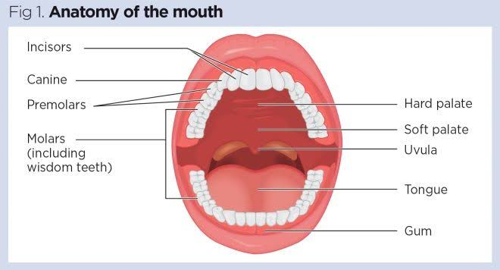Mouth and Oesophagus

There are several functions of the mouth in terms of digestion. Most adults have 32 teeth; eight incisors for ripping/biting off food, four canines to further rip apart the food for easier digestion and eight premolars and 12 molars to help crush up and grind food. When digesting food, saliva plays a large role in the first steps of digestion. As chewing occurs, the mouth and throat begin to secrete saliva from the salivary glands. The saliva’s main function is to help with the breaking down of food as well as helping in tasting. Saliva contains a special enzyme called amylase which breaks down complex carbohydrates into sugars which can be more easily absorbed and lingual lipase which helps break down the fats.

https://www.nursingtimes.net/clinical-archive/gastroenterology/gastrointestinal-tract-1-the-mouth-and-oesophagus-28-05-2019/

The epiglottis is a small “lid” in the back of the mouth and covers the windpipe. The role of the epiglottis is to block food and liquids from entering the windpipe

The oesophagus is a 10 – 13 inch muscle in the centre of the chest connected below the mouth and on top of the stomach. After the food has been swallowed, the oesophagus brings the food down to the lower oesophageal sphincter using waves of muscular contractions. The lower oesophageal sphincter is a ringlike muscle that relaxes and allows food to pass through to the stomach. After food has passed, the muscle contracts to keep the food from flowing back into the oesophagus.

Stomach

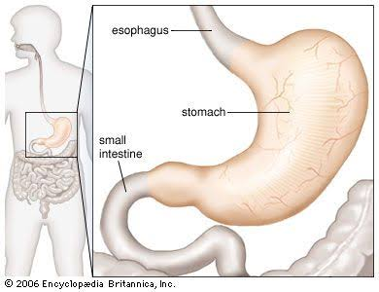The stomach is a J shaped organ that helps in digesting food via chemical and mechanical digestion. Food enters the stomach from the lower oesophageal sphincter and is then mixed and broken down by digestive enzymes; amylase, protease and lipase, which is produced in the pancreas. The amylase breaks down complex carbohydrates, lipase breaks down fats and protease which break down proteins. The food then leaves the stomach as a thick liquid called chyme. With chicken, there is not much carbohydrates that can be broken apart by the amylase, but a large amount of protease and lipase come into play, as chicken has large amounts of proteins that can be digested.

https://www.britannica.com/science/stomach

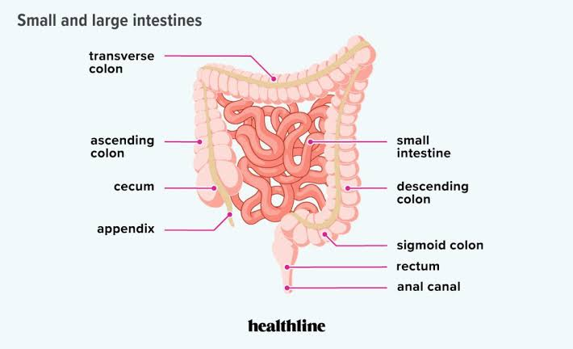Small Intestine (Breakdown)

The food enters the small intestine from the stomach to further break down the nutrients from food. The small intestine mixes chyme (product of food after being broken down in stomach) with digestive juice, bile and pancreatic juice to complete the breakdown of proteins, carbs and fats. The small intestine also mixes water from the bloodstream into the gastrointestinal tract to assist in breakdown

https://www.healthline.com/health/digestive-health/how-long-are-your-intestines

Small Intestine (Absorption)

The small intestine contains small finger-like structures called villi, which line the walls of the intestine to absorb nutrients into the capillaries of the circulatory system and lymphatic system via lacteals. The lacteals absorb fatty acids from the chyme while proteins and carbs are absorbed into the bloodstream through the capillary beds and is taken into the liver for processing.

Material Use

The main use of these nutrients broken down by digestion is energy for the body. Broken down carbohydrates and sugars are absorbed into the bloodstream in the form of glucose. These are used to produce adenosine triphosphate (ATP) through cellular respiration. Cells in the body can then use ATP to power metabolic tasks in the body. Excess glucose from this process can be stored as glycogen in the liver and muscle and released into the blood to maintain blood sugar and energy in the body. Carbohydrates and proteins also combine with other molecules to create substrates and catalyse reactions to help functions such as digestion, muscle repair and contraction and energy production. The fatty acids serve as energy for muscles, heart and other organs. If not used as energy, the fatty acids will be converted into triglycerides for future use.

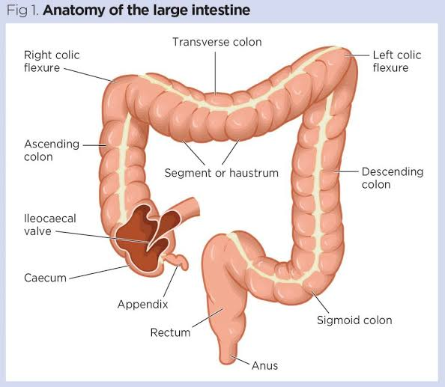Large Intestine

The large intestine consists of the colon, rectum and anus in one long tube that continues from the small intestine to the anal canal. The colon is divided into parts; the cecum, the ascending colon, the transverse colon, the sigmoid colon and the descending colon. When the large intestine receives food from the small intestine, the chyme has been liquified and all nutrients have been absorbed in the small intestine. The main role of the large intestine is to dehydrate the leftover chyme into stool. It does this by slowly absorbing water and electrolytes as the muscles contract and move the waste along the tract. Bacteria in the colon feed on waste and break it down further. The food arrives in the descending colon mostly as a solid.

https://www.nursingtimes.net/clinical-archive/gastroenterology/gastrointestinal-tract-5-anatomy-functions-large-intestine-23-09-2019/

Rectum and Anus

The process of moving the food across the different sections of the intestine takes about 24 hours. The sigmoid colon delivers the dehydrated food waste into rectum, which at this point consists of mostly indigestible matter, dead cells and small amounts of water and mucus. The waste collects in the rectum, where nerves sense if it’s “full” and inform the brain when it’s time to expel it. The rectum then contracts, pushing the waste through the anus and out the body as faeces.

Resources

Alton Memorial Hospital. 2022. Digestive Process. [online] Available at: <https://www.altonmemorialhospital.org/Health-Library/View-Content?contentTypeId=134&contentId=193> [Accessed 8 May 2022].

Hancock Village Dental. 2022. The 5 Types of Teeth. [online] Available at: <https://hancockvillagedental.com/5-types-teeth/> [Accessed 8 May 2022].

Cleveland Clinic. 2022. Esophagus: Anatomy, Function & Conditions. [online] Available at: <https://my.clevelandclinic.org/health/body/21728-esophagus> [Accessed 8 May 2022].